Overview of Performance Reporting for SPDG Grants: NEW Program/GPRA Measure 4
What is this measure’s objective? The purpose of the SPDG Program is to improve results for children with disabilities. If effective professional development is provided to support the use of evidence-based practices, adult behaviors should change in such a way as to improve outcomes for children with disabilities. This measure captures the impact on child outcomes that results from an improvement of implementation of an evidence-based practice.
- This measure is required for all grants that began in Fiscal Year 2020 and those that have been awarded after FY 2020 (i.e., 2021, 2022).
- This measure is developed by the project in coordination with their Project Officer.
- The project also chooses the target for this measure. Targets should be set for the life of the project; however, after each year’s APR is submitted your team should discuss whether the next target makes sense. The project can modify targets in consultation with their Project Officer.
What is the target goal for this measure? Each grantee will set its own target for each reporting year.
What do grantees report in the ED 524B Project Status Chart for each initiative? (See sample below.)
- Performance Measure: Enter the target goal/benchmark for the reporting year of your initiative.
- Measure Type: Enter “Program” to distinguish this GPRA measure from grantee-­‐identified Project measures.
- Target, Ratio: Enter the percentage of children you expect to meet the target benchmark.
- Actual Performance Data, Ratio: Enter the number of children reaching the benchmark set for the target; enter the total number of children served as the denominator.
- Actual Performance Data %: Divide the numerator by the denominator; enter the resulting percentage.
- Explanation of Progress: Provide information that will help explain the quantitative data entered in the chart. Answer the following questions:
  - For each project objective and associated performance measures, indicate what data (quantitative and/or qualitative) were collected and when they were collected, the evaluation methods that were used, and how the data were analyzed. Clearly identify and explain any deviations from your approved evaluation plan, including changes in design or methodology, or the individual or organization conducting the evaluation.

  - Based on your data, provide a description of preliminary findings or outcomes, including information to show whether you are making progress towards meeting each performance measure. Further, indicate how your performance measures data show that you have met or are making progress towards meeting the stated project objective. In your discussion, provide a brief description of your activities and accomplishments for the reporting period that are related to each project objective.

  - If expected data were not attained, expected progress was not made toward meeting a performance measure or project objective, or a planned activity was not conducted as scheduled, provide an explanation. Include a description of the steps and schedules for addressing the problem(s) or issue(s).

  - Indicate how you used your data and information from your evaluation to monitor the progress of your grant, and if needed, to make improvements to your original project plan (e.g., project activities and milestones) which are consistent with your approved objectives and scope of work.

Please see the following example of how to provide Program Measure 4 data in your status chart taken from Idaho’s sample 524B Status Charts:

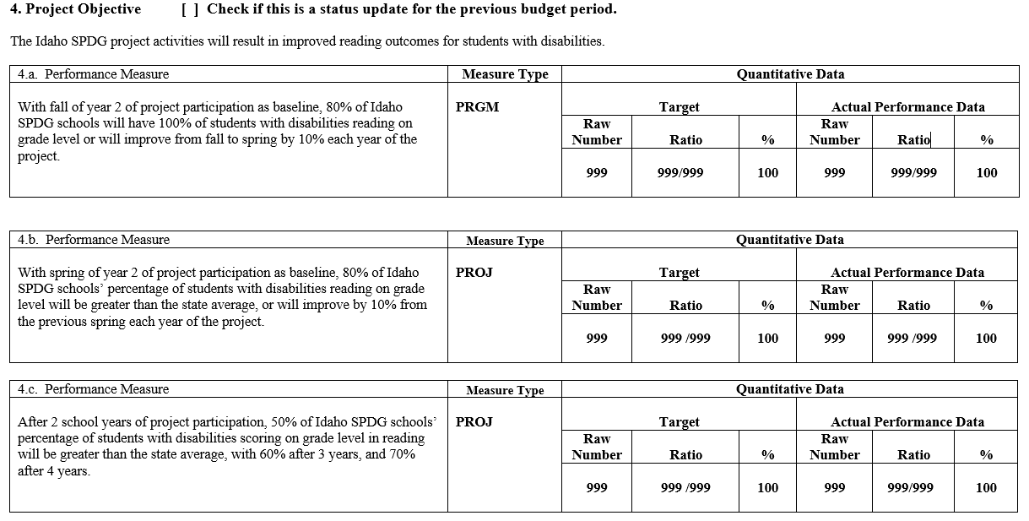

8

