<https://depictdatastudio.com/how-to-write-your-reports-in-powerpoint/>

**How to Write Your Reports in PowerPoint Instead of Word: Nine Tips for Getting Started**



[Nick Visscher](https://depictdatastudio.com/author/nickvisscher/)

*Apr 3rd, 2018 /*[*Data Visualization*](https://depictdatastudio.com/category/data-visualization/)*,*[*Reports*](https://depictdatastudio.com/category/reports/)*/*[*Guest Posts*](https://depictdatastudio.com/tag/guest-posts/)*,*[*Microsoft PowerPoint*](https://depictdatastudio.com/tag/microsoft-powerpoint/)*,*[*Microsoft Word*](https://depictdatastudio.com/tag/microsoft-word/)*,*[*Photographs*](https://depictdatastudio.com/tag/photographs/)*,*[*Presentations*](https://depictdatastudio.com/tag/presentations/)*,*[*Reports*](https://depictdatastudio.com/tag/reports/)*,*[*Slideshows*](https://depictdatastudio.com/tag/slideshows/)*,*[*Software*](https://depictdatastudio.com/tag/software/)



Hi! My name is Nick Visscher, I’m an internal evaluator with Denver Zoo. Our data work spans the gamut from collecting guest satisfaction insights to observing preschool kids in our nature play programming. With everything our team does we aim to help our staff improve their programs and our guest’s experience. It’s important for us to disseminate our findings in ways that make our stakeholders (mainly internal staff) to dig in and explore. Clear, concise, and well visualized reporting is super important and something we are passionate about.

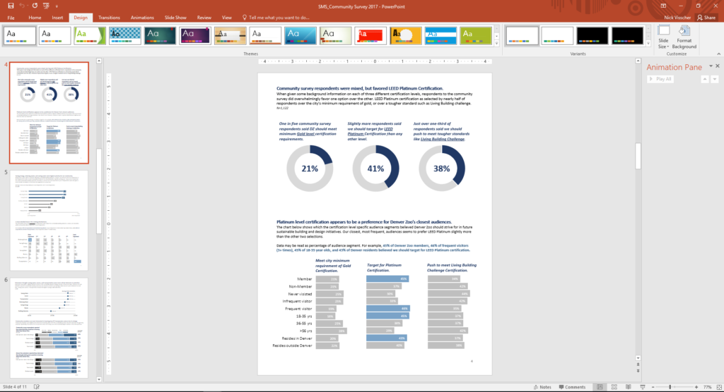

There are so many options when it comes to reporting software, but one familiar face I often find myself turning to is Microsoft PowerPoint. You might not immediately think of PowerPoint when it comes to creating formal reports, but I love using it in lieu of more common applications like Word. Positioning new images and text boxes into a document is just easier in PowerPoint. You don’t need to worry about anchoring items or how inserting new text might change the position of items you’ve already included on a page. It’s a blank canvas without many limitations.

Here are some screenshots from a report that I wrote in PowerPoint. These pages come from our *Lorikeet Adventure: Guest Experience Research Brief.*

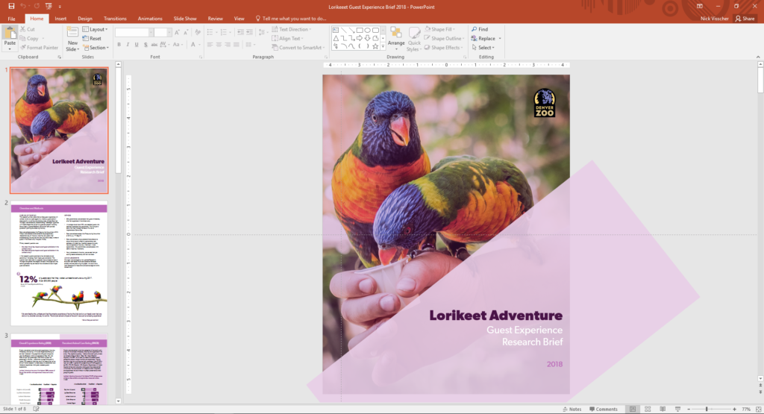

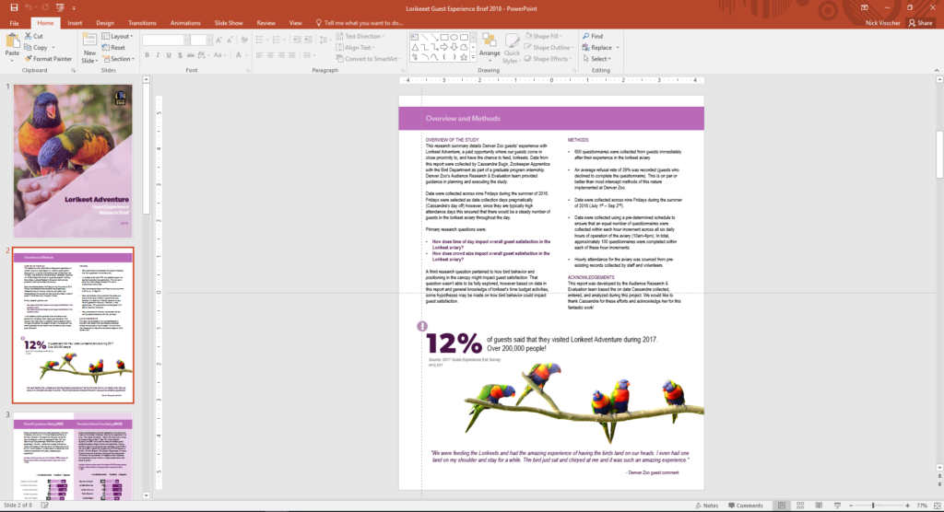

Here are a few tips I keep in mind when using PowerPoint to design my evaluation reports. Note: I’m working in MS Office 2016.

1. **Changing slide orientation**: I like a traditional page layout for a report I know my readers will likely print, not the default slide size (16:9 aspect ratio). To change it, I go to the Design pane and create a custom slide size, change the settings to 8.5” by 11”, and select a Portrait orientation.
2. **Making use of the page ruler, gridlines, and guides**: In the View pane I always select Ruler and Guides (and sometime Gridlines) so I can make sure key text and objects are in the same position on each page. I also know my readers will likely print and use a staple in the upper left corner so I make sure to keep one guide line at a half inch from the left. This lets me position headers and text where I know a staple won’t get in the way.
3. **Using built in arrangement options for multiple text boxes or images**: Don’t spend too much time clicking that left arrow or right arrow to “nudge” objects into just the right place on a page. Select all the objects you wish to align, go to the Home pane, select Arrange, and then select Align. There are built in arrangement options there which perfectly align or evenly distribute everything at once. This is one feature that consistently saves me time and makes everything look better.
4. **Inserting shapes and lines as design elements**: I love using basic shapes and lines in different variations on a page to give the design of a report a sleek and professional feel. I avoid predefined slide design templates at all costs, they don’t often follow the principles of good design.
5. **Using fill color and transparency**: I’m not always confident in knowing which colors compliment each other so to avoid having to pick different colors, but still give some visual variation, I increase the degree of fill color transparency on key shapes or objects. I also like doing this on cover pages when most often the entire slide background is a photograph. Inserting overlapping shapes with 50% transparency creates a sophisticated visual effect and also adds some darker space on the page perfect for a title or text header to stand out.
6. **Copying page design for the whole report**: Most of the time I like my background design and title text to be consistent on each page. Once I’ve created a page layout I like I simply copy and paste that slide for the remainder of the report pages. This is a quick solution to having to re-create the most common design elements in your report over and over again. I’ve used a more elegant solution lately by editing the slide master in the View pane and editing the default fonts and colors in the Design pane.
7. **Editing dataviz directly in PowerPoint**: I used to spend a lot of time editing charts directly in Excel, then copy/pasting them into PowerPoint. This would sometimes cause size and formatting issues so I’d have to do a few edits there too. PowerPoint has the same chart editing and layout features as Excel does so now I create a basic default chart in Excel using my data, copy/paste that right away into PowerPoint, and do all of my editing there.
8. **Letting your copy editor do their thing**: I always need a copy editor when I finish a report. PowerPoint provides similar review and comment features as Word does. It’s not quite as extensive but it does the trick. Under the Review pane you can select text, add comments, and select “start inking” to highlight areas is the report that need further attention.
9. **Saving your report**: Save your report as a PDF or XPS document when you’re ready to send to your readers. They’ll be dazzled by the beauty of your work and be none the wiser that you used trusty ole PowerPoint to design it.

Here’s another report that I designed within PowerPoint. These pages come from our *Zoo Lights: Guest Experience Survey Report*.

