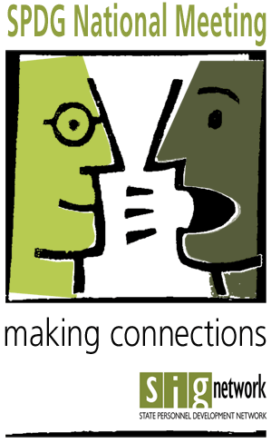
AGENDA
Meeting Objectives:
- Increase knowledge and skills related to:
  - Family Engagement, and
  - Data-based Decision Making
- Increase knowledge of and ability to use new tools
- Build a stronger program network
8th Annual SPDG National Meeting
FHI 360 Conference Center • 1825 Connecticut Avenue NW • 8th Floor • Washington, DC
October 10-11, 2018
Strands: Family Engagement & Data Based Decision Making
Pre-Meeting: October 9

5:30 – 6:30 pm Registration Courtyard Marriott
5:00 – 8:00 pm Informal Group Meet Up Board Room: 1737 Connecticut Avenue

Day One: October 10

8:00 – 9:00 Registration Academy Hall, FHI 360 Conference Center, 8th Floor
8:30 – 9:00 New Participant Orientation Vista B
Steve Goodman, Ph.D., MI SPDG Director

9:00 – 9:20 Conference Overview and Introduction to Family Engagement Discussion Academy Hall
Jennifer Coffey, Ph.D., SPDG Program Area Lead, OSEP
John Lind, SIGnetwork Coordinator
9:20 – 9:25 Transition
9:25 – 10:15 Family Engagement Golden Circle Activity Academy Hall
Golden Circle Activity Handout on Tables
10:15 – 10:30 Sharing & Transition
10:30 – 11:30 Family Engagement Keynote Academy Hall
Dr. Linda Karges-Bone. Education InSite
11:30 – 12:00 Facilitated Family Engagement Planning Time Academy Hall and Breakout Rooms
12:00 – 1:30 Lunch – On your own
1:30 – 1:45 Welcome back and preview of afternoon breakout sessions
Project Max Video
1:45 – 2:40 Community Meetings Evaluators Academy Hall
Coaching Vista A
SSIP-SPDG Vista B
Family Engagement Balcony D
Activity for those not in a community Balcony E

2:40 – 2:50 Transition
2:50 – 3:20 Forum Breakout, Session 1 Break out Spaces
Details in Booklet, Forum Schedule See Booklet for Location
3:20 – 3:35 Sharing & Transition
3:35 – 4:05 Forum Breakout, Session 2 Break out Spaces
Details in Booklet, Forum Schedule See Booklet for Location
4:05 – 4:15 Transition
4:15 – 5:00 Consultancy Protocol Session Break out spaces
Details in Booklet See Booklet for Location
5:15 – 7:00 Optional Networking at Russia House 1800 Connecticut Ave NW
Corner of Connecticut & Florida Ave NW
Day Two: October 11
8:30 – 8:45 Welcome from Larry Wexler and Overview of Day’s Agenda Academy Hall
8:45 – 8:55 Transition
8:55 – 9:15 10 & 10 Breakout Sessions (2) Breakout Spaces
Details in Booklet See Booklet for Location

9:15 – 9:30 Transition

9:30 – 9:50 10 & 10 Breakout Sessions (2) Breakout Spaces
Details in Booklet See Booklet for Location

9:50 – 10:00 Transition
10:00 – 11:00 Team Time Academy Hall
11:00 – 11:15 Jennifer Coffey and John Lind Academy Hall
11:15 – 12:00 Systems that Support Collaboration with Families Academy Hall Rene Averitt-Sanzone, Executive Director of Parents’ Place Maryland

